Set up application
Open source code with Android Studio
Click run button to test app. There are 4 main features in application is clean device, manage application, battery saver and manage background app.
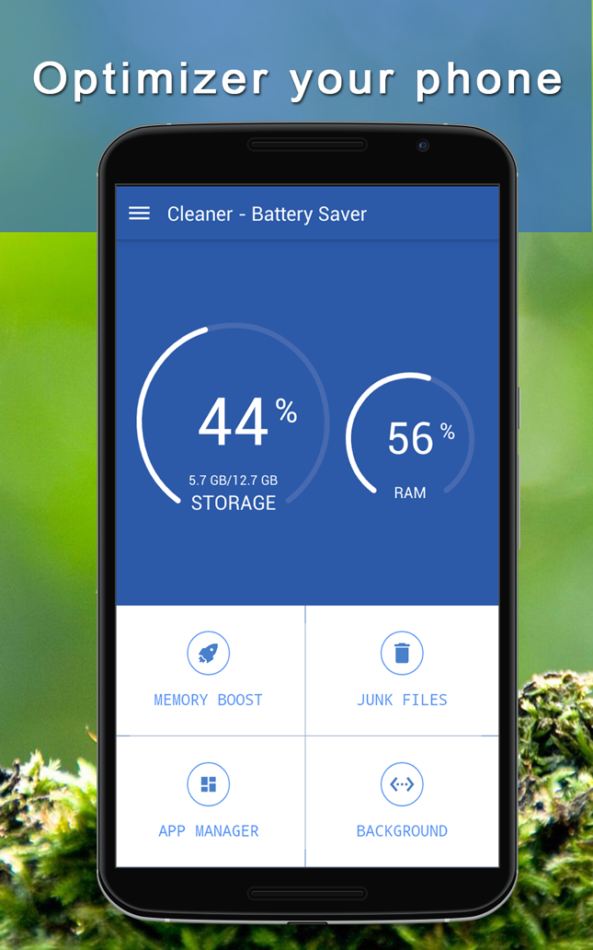

You can change these feature by change activity: MemoryCleanActivity.java, RubbishCleanActivity.java, SoftwareManageActivity.java and AutoStartManageActivity.java.
To reskin application:
- Change package of application
- Change logo and icon of application
- Change id admob in res/values/strings.xml file.
- Change some color by change values in colors.xml
- Change the name of application

